

BSc (Hons) Computer Science
CIS013-3 Research Methodologies and Emerging Technologies

Fixora - Multi-Agent Artificial Intelligence-Based Automated Administrative System for Enterprise Business Operations

Contextual Report
Student Name: R M Ishini Tharushika Rathnayake
Student ID: 2521838
Date of Submission: 26th April 2025

Table of Contents
1. Chapter 1: Introduction 5
1.1. Project Background 5
1.1.1. Motivation 5
1.1.2. Research Problem 5
1.2. Aim 6
1.3. Objectives 6
1.4. Description of the Artifact 6
1.4.1. Scope 6
1.4.2. How the Problem Will Be Solved 6
1.5. Structure of the Report 7
2. Section 2: Literature Review & Market Research 8
2.1. Literature Review 8
2.1.1. Introduction 8
2.1.2. Multi-Agent Systems in Enterprise Applications 8
2.1.3. Artificial Intelligence in IT Operations (AIOps) 9
2.1.4. Log Analysis and Error Detection Techniques 10
2.1.5. Natural Language Interfaces for System Administration 12
2.1.6. Research Gap and Literature Conclusion 13
2.2. Market Research 14
2.2.1. Data Gathering 14
2.2.2 Requirement Analysis — Non-IT Staff (Business Users, n = 50) 15
2.2.3 Requirement Analysis — IT Staff and Developers (n = 34) 20
2.2.4 Open-Ended Responses 23
2.2.5 Requirements Derived from Market Research 24
2.2.6 Market Research Conclusion 25
3. Section 3: Project Plan 26
3.1. Description of the Project Plan 26
3.2. Gantt Chart 26
3.3. Work Breakdown Structure (WBS) 26
4. Section 4: Planning Your Artifact 28
4.1. Methodology 28
4.2. Planning 28
4.3. Requirement Gathering and Analysis 28
Proposed Conceptual Framework 29
Illustrative Use Case Scenario 29
4.4. Design 30
4.5. Implementation 31
4.6. Testing and Evaluation Strategy 32
4.7. Risks and Risk Mitigation 33
5. References 35
6. Appendices 37
6.1. Appendix A: Questionnaire/Interview Questions 37

List of Figures
Figure 1: Participant Role Distribution — Survey Respondents (n = 84). 15
Figure 2: Frequency of System Issues — Survey Respondents (n = 50). 16
Figure 3: Types of Issues Experienced — Survey Respondents (n = 50). 16
Figure 4: Challenges in Establishing Cause — Survey Respondents (n = 50). 17
Figure 5: Impact on Work — Survey Respondents (n = 50). 17
Figure 6: Time to Resolution — Survey Respondents (n = 50). 18
Figure 7: Problems When Contacting IT Staff — Survey Respondents (n = 50). 19
Figure 8: Non-IT Staff — Preferred AI System Features (n = 50). 19
Figure 9: IT Staff — Systems Worked With SAP (n = 34). 20
Figure 10: IT Staff — Systems Worked With SAP Modules (n = 34). 20
Figure 11: IT Staff — Common Issues Handled (n = 34). 21
Figure 12: IT Staff — Useful AI Features (n = 34). 23
Figure 13: Project Gantt Chart — Tasks, Subtasks, Milestones, Start and End Dates 26
Figure 14: Work Breakdown Structure (WBS) 26
Figure 15: High-Level Conceptual System Architecture of the Proposed Multi-Agent AI System. 30

List of Tables
Table 1: Comparative Analysis of Monitoring Tools and the Proposed System. 14
Table 2: Survey Participant Role Distribution 15
Table 3: Requirements Derived from Survey Evidence 24
Table 4: Technologies and Tools Selected for System Implementation 31
Table 5: Risk Register and Mitigation Strategies 33

1. Chapter 1: Introduction
This section introduces the research project titled ‘Multi-Agent Artificial Intelligence Based Automated Administrative System for Enterprise Business Operations’. It establishes the background and motivation for the research, identifies the research problem, states the project aim and objectives, describes the proposed artefact, and outlines the structure of this contextual report.

1.1. Project Background

1.1.1. Motivation
Modern enterprise organisations operate large, interconnected digital ecosystems — databases, web applications, mobile applications, and distributed backend microservices — all functioning simultaneously to support core business operations. The increasing complexity of these environments has made administrative management considerably more demanding. When technical faults arise, resolving them typically requires the involvement of highly specialised personnel, creating bottlenecks that result in costly downtime and operational disruption. This challenge is experienced not only by IT departments but also by business users who depend on these systems for day-to-day work.
The motivation for this research arises from a clearly identifiable gap between what current enterprise monitoring tools offer and what organisations genuinely need. Platforms such as Datadog, Splunk, and New Relic are capable of collecting and presenting operational metrics, but they are fundamentally reactive and non-explanatory. They alert administrators to problems but provide no intelligent reasoning about causes or remediation. For non-technical users this gap is considerably wider. They often can’t make sense of system failures and have to wait for specialists to get involved. Advances in Artificial Intelligence — specifically, the creation of massive language models and multi-agent coordination frameworks — present a compelling chance to address these limitations. A system composed of autonomous, collaborating AI agents capable of monitoring activity, analysing logs, diagnosing faults, and responding to natural language queries has the potential to fundamentally change how enterprises manage their technical infrastructure.

1.1.2. Research Problem
The core research problem addressed by this project is: existing enterprise system monitoring and administration tools lack the intelligent, interactive, and automated capabilities required to support administrators — particularly those without deep technical expertise — in diagnosing, understanding, and resolving system issues. Specifically, the following deficiencies are identified:
- Current monitoring platforms provide data and alerts but offer no intelligent interpretation, reasoning, or resolution guidance.
- Multi-agent AI systems are highly explored in theory, but not broadly deployed in the actual context of company administration.
- Natural language interfaces for system administration remain shallow; they are not fused with deep analytical intelligence.
- Traditional commercial monitoring solutions do not offer root cause analysis and automatic problem remediation.
- Existing tools require a significant level of technical competence to interpret their outputs, effectively preventing non-technical users from meaningful participation in system administration.

1.2. Aim
The aim of this project is to develop a multi-agent artificial intelligence based automated administrative system to assist enterprise organisations in monitoring system activities, analysing operational data, and diagnosing technical issues efficiently through a user-friendly natural language interface.

1.3. Objectives
- To analyse the needs and requirements of enterprise system administration through literature review and primary market research.
- To design a modular multi-agent AI-based system architecture using established software engineering principles.
- To integrate the system with a sample enterprise application and database using RESTful APIs.
- To develop an automated log analysis and error detection mechanism using NLP and machine learning techniques.
- To create a user-friendly dashboard interface enabling visualisation of system health and agent activity.
- To implement a natural language querying capability allowing administrators to interact using plain English.
- To evaluate the effectiveness of AI-assisted debugging, diagnostic accuracy, and system usability through structured testing.

1.4. Description of the Artifact

1.4.1. Scope
The artefact is a functional prototype of a Multi-Agent AI-Based Automated Administrative System, demonstrating the feasibility and practical value of applying multi-agent AI to enterprise system administration. The prototype will be developed and evaluated using sample enterprise datasets, including publicly available server log data from Kaggle, simulating a representative enterprise environment encompassing a relational database, a backend application, and associated log files.
The scope encompasses: a multi-agent AI backend orchestrated using LangChain; a Monitoring Agent for continuous log ingestion and threshold-based monitoring; an Analysis and Diagnostic Agent applying NLP and ML for anomaly detection and root-cause generation; a Data Retrieval Agent for natural language-to-database querying; integration with a MySQL database and simulated API endpoints via FastAPI; a React.js dashboard providing real-time visualisation; and role-based access control (RBAC) supporting administrator and viewer roles.

1.4.2. How the Problem Will Be Solved
The proposed system addresses the research problem through a layered architecture in which specialised agents handle discrete administrative tasks collaboratively, coordinated by a LangChain orchestration layer. The Monitoring Agent processes log streams and raises contextualised alerts. The Analysis Agent uses pre-trained NLP and anomaly detection models to give explanatory diagnostic feedback in simple English. With the Data Retrieval Agent, non-technical users can query the operational database without SQL knowledge. The frontend dashboard unifies agent outputs into a single display, directly tackling the tool fragmentation pointed out by survey respondents (Section 2.2). This architecture provides an intelligent, accessible administrative system substantially more autonomous than current commercial alternatives.

1.5. Structure of the Report
- Section 2 — Literature Review and Market Research: Critically reviews academic and industry research on MAS, AIOps, log analysis, and NLP interfaces, and presents primary survey findings from 84 respondents with data analysis and requirement derivation.
- Section 3 — Project Plan: Presents the Gantt chart with tasks, subtasks, and milestones, the WBS, and a summary of completed and pending work.
- Section 4 — Planning the Artefact: Covers development methodology, requirements, design approach, implementation plan, testing and evaluation strategy, and risk management.
- References:
- Appendix A: Full market research questionnaire and selected open-ended responses.

2. Section 2: Literature Review & Market Research

2.1. Literature Review

2.1.1. Introduction
This literature review critically discusses the existing work and knowledge in four areas related to the proposed system: multi-agent systems in enterprise applications, artificial intelligence techniques in IT operations (AIOps), automated log analysis and error detection, and natural language interfaces for system administration. The review was conducted between February and March 2026 using IEEE Xplore, Google Scholar, and Scopus. The search terms used were: ‘multi-agent systems enterprise administration’, ‘AIOps anomaly detection’, ‘log analysis machine learning’, ‘natural language interface IT operations’, and ‘enterprise system monitoring automation’. Sources were selected from peer-reviewed journals and conference proceedings; seminal foundational works were included regardless of publication date. The purpose is not merely to summarise previous work but to review it critically, drawing attention to limitations that justify the proposed research.

2.1.2. Multi-Agent Systems in Enterprise Applications
Multi-Agent Systems (MAS) is a well-established field of Artificial Intelligence in which several autonomous agents sense their environment, reason independently, and collaborate to achieve collective goals (Wooldridge and Jennings, 1995; Wooldridge, 2012). Their applicability to complex, dynamic enterprise environments has been extensively acknowledged (Shoham and Leyton-Brown, 2009; Russell and Norvig, 2021).
Joshi (2025) provides a comprehensive review of autonomous and collaborative agentic AI for enterprise applications, demonstrating how multi-agent systems can automate workflows across procurement, human resource management, and financial processing, reporting efficiency gains of 40–60% in enterprise process automation. A central strength is agent adaptability: unlike fixed rule-based systems, agents dynamically modify their behaviour based on real-time conditions, allowing for more responsive operations. This is corroborated by Dorri et al. (2018), whose survey of MAS demonstrates that agents equipped with planning and self-evaluation mechanisms can analyse operational data in real time, improving both system responsiveness and decision quality. However, it is important to critically note that Joshi (2025) relies predominantly on industry white papers and commercial case studies rather than controlled empirical evaluations, which limits the generalisability of the reported efficiency figures to diverse enterprise contexts. Where Joshi (2025) addresses strategic deployment, Dorri et al. (2018) provide the foundational technical basis for agent coordination mechanisms; together, the two perspectives confirm that MAS offers both strategic and operational value, though independent replication of performance claims in heterogeneous IT environments remains limited in the existing literature.
Notaro, Cardoso and Gerndt (2021), in their systematic mapping study of AIOps and agent-based monitoring solutions, show how agent-based cloud architectures can dynamically scale with workload, overcoming the inherent limits of classical monolithic systems. This finding is further contextualised by Benfield, Hendrickson and Galanti (2006), who document that agent interoperability across heterogeneous technology stacks is essential for coordinating large IT infrastructures, and that commercially deployed MAS can substantially reduce total cost of ownership compared with conventional enterprise software. Critically, however, Benfield et al. (2006) present evidence drawn from a single commercial BDI-based platform (AdaptivEnterprise), which constrains the applicability of their findings to alternative MAS architectures. Their cost-reduction claims have not been systematically replicated across independent deployments, a limitation that must be acknowledged when drawing on this work to justify MAS investment in novel enterprise contexts.
However, significant challenges remain. Dorri et al. (2018) observe that coordination overhead increases substantially as the number of concurrently operating agents grows, potentially introducing consistency errors, race conditions, and communication latency. This scalability concern is not adequately addressed by either Joshi (2025) or the commercial case studies reviewed: reported deployments operate in well-defined, bounded task domains rather than the open-ended, real-time diagnostic environments that enterprise system administration demands. Joshi (2025) further argues that governance and security frameworks must be robust when agents operate over sensitive enterprise data, yet neither the governance models nor the security validation approaches are described in sufficient technical detail to be directly applicable. Critically, while MAS theory is mature and well-established, the reviewed literature contains a conspicuous and important gap: there is no empirical evidence of a deployed MAS specifically targeting real-time enterprise system administration through the integrated combination of log analysis, NLP querying, and automated diagnostics within a unified architecture. This precise gap is what the proposed system is designed to address.

2.1.3. Artificial Intelligence in IT Operations (AIOps)
AIOps — the application of machine learning, data analytics, and AI to IT operations — has emerged as a significant area of both academic research and commercial development. By processing large volumes of operational data automatically, AIOps platforms aim to improve anomaly detection rates, accelerate incident resolution, and reduce the burden of manual monitoring.
Dang, Lin and Huang (2019), reporting from large-scale production experience at Microsoft, provide an authoritative account of the real-world challenges of building AIOps solutions. They demonstrate that AIOps can substantially improve service quality and engineering productivity by automating pattern recognition across operational data streams that would be infeasible to monitor manually. Crucially, they identify two persistent structural limitations that directly motivate the proposed research: first, current AIOps platforms are architected primarily to detect and report issues rather than resolve them autonomously; and second, the limited explainability of AI-generated alerts means that human expert intervention remains necessary for final decision-making. It is important to note, however, that Dang et al. (2019) present findings from a single technology organisation (Microsoft), and the operational conditions, data volumes, and tooling maturity at that scale may not generalise to small and medium-sized enterprises or to heterogeneous on-premise deployments — the more typical context for the enterprise systems addressed in this research. These structural limitations nonetheless align strongly with the primary survey findings reported in Section 2.2, where 70.6% of IT respondents cited difficult log analysis as the primary limitation of their current tools, confirming that the gap identified by Dang et al. (2019) is reproduced in the target environment of the proposed system.
Notaro et al. (2021), whose systematic mapping of AIOps contributions across academic and commercial literature confirms the findings of Dang et al. (2019), further demonstrate that the AIOps field has grown substantially since the term was coined in 2016–2017, with the majority of contributions addressing failure-related detection tasks (62% of identified works). However, Notaro et al. (2021) make a significant critical observation: automated resolution — as opposed to mere detection — remains largely absent from the published literature across both academic and commercial AIOps contributions. This finding is consistent across the reviewed body of evidence and is not contradicted by any of the sources examined, lending it substantial weight as an evidence-based justification for the proposed Diagnostic Agent. A limitation of Notaro et al.’s (2021) mapping study, however, is that it was conducted on literature up to 2020; the field has evolved rapidly since then, and the proposed system must account for the possibility that resolution-capable AIOps tools may have emerged commercially since the mapping was completed.
A further critical limitation across the reviewed AIOps literature is that system effectiveness is heavily contingent on training data quality. Poorly labelled or unrepresentative data produces high false-positive alert rates, eroding user trust and undermining operational value. Dang et al. (2019) identify this as one of the most practically damaging challenges in production AIOps deployments, noting that the absence of reliable ground-truth labels is a systemic problem rather than an isolated edge case. This concern is directly relevant to the proposed system: the Kaggle log datasets used for prototype testing must be rigorously validated, pre-processed, and annotated with ground-truth anomaly labels before being used for model training, as specified in the data pipeline design in Section 4.5. Failure to address data quality at this stage would undermine the reliability of the Analysis Agent’s outputs and compromise the validity of the evaluation results.

2.1.4. Log Analysis and Error Detection Techniques
Application logs represent one of the richest sources of operational intelligence available in enterprise systems. However, the volume, velocity, and structural variability of log data generated by modern distributed systems renders manual analysis wholly impractical — a finding that is confirmed by the primary survey data presented in Section 2.2, where 73.5% of IT respondents identified log analysis as their primary root-cause identification method, yet simultaneously 70.6% cited difficult log analysis as the leading limitation of their current tools. This paradox reveals a significant tool quality gap that the proposed Analysis Agent is designed to bridge.
Xu et al. (2009), in a seminal paper from the ACM SIGOPS Symposium on Operating Systems Principles, propose a general methodology for mining console logs by combining source code analysis with information retrieval to create structured composite features, which are then analysed using Principal Component Analysis (PCA) to detect operational anomalies automatically. Their evaluation on large-scale Hadoop deployments demonstrates that feature-based ML applied to parsed log data can detect anomalies invisible to manual inspection. This work establishes a foundational principle for the Monitoring and Analysis Agent design: that structured feature extraction from raw logs, combined with trained classifiers, can reliably identify abnormal system states. A notable limitation of Xu et al.’s (2009) approach, however, is its reliance on access to application source code to generate parsing templates, which constrains applicability in closed-source enterprise environments such as SAP. The proposed Analysis Agent will therefore adopt a source-code-agnostic log parsing strategy — specifically the Drain algorithm (He et al., 2017) for structured log template extraction — followed by Isolation Forest for unsupervised anomaly detection, which is well-suited to high-dimensional log feature spaces and does not require labelled training data for initial deployment.
He et al. (2016), in an experience report from the IEEE International Symposium on Software Reliability Engineering that received the Most Influential Paper Award, provide a rigorous comparative evaluation of six log-based anomaly detection methods — including Invariant Mining, Log Clustering, PCA, Decision Trees, SVM, and LogKey — evaluated on two publicly available production log datasets comprising over 15.9 million log messages. Their findings reveal that no single method dominates across all scenarios: supervised methods (Decision Tree, SVM) achieve higher precision when labelled data is available, whereas unsupervised methods (Invariant Mining, PCA) offer greater flexibility at the cost of higher false-positive rates. Critically, He et al. (2016) note that the performance gaps between methods narrow considerably when log data quality is low, a finding that reinforces the data validation requirements discussed above. This empirically grounded trade-off directly informs the hybrid approach proposed for the Analysis Agent: Isolation Forest will be used for unsupervised detection of novel anomaly patterns, while a trained Random Forest classifier will be applied to known anomaly classes where labelled ground-truth data is available from the Kaggle dataset.
Fu et al. (2009), at the IEEE International Conference on Data Mining, propose an unstructured log analysis technique based on finite state automata (FSA) to detect execution sequence anomalies in distributed systems without requiring application-specific knowledge. Their approach converts free-form log messages to abstract log keys through clustering, then constructs an FSA model of normal execution behaviour from training sequences, flagging deviations as anomalies. In contrast to Xu et al.’s (2009) feature-based PCA approach, which detects statistical deviations in log message frequency distributions, Fu et al.’s (2009) control-flow model captures sequential workflow violations — for example, a database transaction that skips expected commit steps. This complementary perspective is important: it demonstrates that no single detection paradigm is sufficient, and that robust anomaly detection requires the integration of both statistical and sequential analysis methods. The proposed Analysis Agent will incorporate this insight by applying workflow sequence modelling — using a log template-to-sequence encoding pipeline — alongside statistical feature analysis, enabling detection of both data-plane and control-plane anomalies.
Cinque, Cotroneo and Pecchia (2013), in the IEEE Transactions on Software Engineering, present a rule-based approach to event log instrumentation and analysis, demonstrating that systematically instrumented logs contain sufficient diagnostic information for failure analysis and mitigation strategy development. Critically, however, they identify that ad hoc and inconsistent logging practices — endemic in most real-world enterprise codebases — frequently result in logs that are structurally irregular, semantically incomplete, or temporally misaligned, threatening the validity of any log-based diagnostic approach. This finding is particularly significant for the proposed system: it means that raw log ingestion cannot proceed without a robust pre-processing pipeline. In contrast to the idealised conditions assumed by Xu et al. (2009) and He et al. (2016), whose evaluations rely on clean, well-structured benchmark datasets, the proposed system must implement a realistic pre-processing pipeline encompassing timestamp normalisation, log deduplication, template extraction via Drain, and anomaly label annotation — all described in Section 4.5.
A consistent and critical limitation emerges across all four of the above foundational studies: each technique is confined to anomaly detection and, in some cases, root-cause localisation, but none generates a plain-language explanation of why an anomaly occurred or recommends a specific remediation action. Xu et al. (2009) surface anomalous PCA deviations; He et al. (2016) classify log sequences as normal or abnormal; Fu et al. (2009) flag FSA violations; Cinque et al. (2013) identify failure-relevant log events. Across all four, the output is a binary or categorical label — not an actionable, human-readable diagnostic. This gap is not addressed by any of the commercial platforms reviewed (Table 1), nor by the AIOps literature surveyed in Section 2.1.3. It constitutes the central technical contribution of the proposed Diagnostic Agent, which will combine the detected anomaly signal from the Monitoring Agent with Grok (xAI)-generated natural language reasoning — prompted with structured log context, anomaly type, and historical resolution data — to produce an actionable, plain-English root-cause hypothesis.

2.1.5. Natural Language Interfaces for System Administration
Natural Language Interfaces (NLIs) offer a pathway to democratising access to complex technical systems by enabling interaction through everyday language rather than specialised command syntax. For enterprise system administration, this is particularly significant: non-technical users could query system status, retrieve operational data, and initiate diagnostic workflows without specialist knowledge — directly addressing the accessibility gap identified in the survey data (Section 2.2).
Manaris and Dominick (1993) identified syntactic rigidity as a fundamental early barrier to NLI adoption, observing that systems requiring users to conform to rigid command grammars produced frustrating failure modes when natural linguistic variation was encountered. While this work is chronologically distant, its diagnostic value lies not in proposing a technical solution — the authors’ own NALIGE system remains a domain-specific, grammar-driven tool with narrow coverage — but in establishing a persistent design principle: any NLI system intended for non-specialist users must accommodate natural linguistic variation rather than requiring users to adapt to system-imposed syntax. The relevance of this principle to the proposed system is direct: business users querying the Data Retrieval Agent will use informal, domain-mixed natural language (e.g., “show me the slowest database jobs from yesterday”), not structured query syntax, and the NLP layer must handle such variability robustly.
Mazumder et al. (2019), in their work on lifelong and interactive learning of factual knowledge in dialogue systems, demonstrate that NLI systems face compounding challenges as operational environments evolve: knowledge bases become stale, entity references shift, and contextual dependencies accumulate in ways that static, pre-trained models cannot handle without continuous knowledge updating. Their dialogue-based evaluation shows that models relying on fixed knowledge representations degrade measurably in accuracy as entity information changes — directly relevant to enterprise system administration, where database schemas, service names, and configuration parameters change with each deployment cycle. Critically, however, Mazumder et al. (2019) evaluate their approach in a factual QA over product entities domain rather than in system administration, which limits the directness of the transfer. The proposed Data Retrieval Agent will address the knowledge-staleness problem through schema-aware prompt engineering: rather than relying on a static fine-tuned model, the agent will inject the current MySQL schema, table definitions, and system glossary into the Grok (xAI) context window at query time, ensuring SQL generation always reflects the current state of the operational database.
These historical limitations partially explain why only 32.4% of IT survey respondents selected natural language interaction as a useful AI feature — suggesting that current NLI implementations in enterprise contexts have not yet earned full practitioner trust. However, this lower selection rate should be interpreted cautiously: it may reflect practitioners’ unfamiliarity with recent LLM capabilities rather than a fundamental rejection of the concept. The non-IT cohort, by contrast, showed strong preference for both a simple interface (88%) and natural language queries (86%), indicating that accessibility through plain language is strongly valued by the non-technical users who would benefit most from such a feature.
The advent of large language models such as Grok (xAI) has substantially mitigated the syntactic and semantic limitations documented by Manaris and Dominick (1993) and Mazumder et al. (2019). Grok demonstrates strong contextual reasoning, handles linguistic ambiguity through in-context learning, and generalises across technical domains with minimal task-specific fine-tuning (xAI, 2025). In the proposed architecture, Grok functions as the linguistic orchestration layer: natural language queries from administrators are processed by Grok into structured agent instructions via prompt engineering, and the outputs of the Monitoring and Analysis Agents are passed back through Grok to generate plain-English diagnostic summaries. It must be acknowledged, however, that LLM-based NLP introduces new risks not present in the grammar-driven systems of Manaris and Dominick (1993): specifically, hallucination (generating plausible but incorrect SQL or diagnostic outputs), context window limitations, and API latency. These risks will be addressed in the proposed system through output validation — all Grok-generated SQL will be schema-validated and sandboxed before execution — and through the evaluation strategy in Section 4.7, which measures NLP query accuracy against ground-truth SQL equivalents across 30 test cases of varying complexity.

2.1.6. Research Gap and Literature Conclusion
The literature reviewed reveals a consistent and significant pattern: MAS, AIOps, log analysis, and NLP interfaces have each been studied with rigour, but in disciplinary isolation. Each domain has produced technically valuable contributions, yet none has produced — nor attempted — a system that integrates all four capabilities into a unified, intelligent enterprise administrative architecture. This fragmentation is not merely a matter of omission: it reflects a genuine structural gap in the academic and commercial landscape, one that is empirically confirmed by the primary survey data in Section 2.2 (88.2% of IT staff found root-cause identification at least moderately difficult; 82.4% endorsed AI-based automation; 92% of non-IT users confirmed AI error explanation would be useful). The specific, evidence-based gaps identified are:
- Multi-agent architectures remain largely theoretical in the enterprise system administration domain; practical deployments are rare (Joshi, 2025; Dorri et al., 2018).
- AIOps platforms detect anomalies but do not autonomously resolve them or provide plain-language explanations; human intervention remains necessary for decision-making (Dang et al., 2019; Notaro et al., 2021).
- Log analysis techniques focus on detection and classification but do not generate actionable root-cause explanations or resolution guidance (Xu et al., 2009; He et al., 2016; Fu et al., 2009; Cinque et al., 2013).
- NLP interfaces are not yet deeply integrated with backend analytical intelligence in administrative tools; semantic parsing limitations and lack of domain-specific training remain barriers (Mazumder et al., 2019; Manaris and Dominick, 1993).
- Commercial monitoring platforms — Datadog, Splunk, and New Relic — require significant technical expertise to interpret and act upon their outputs, excluding non-technical users from meaningful participation in system management.
The proposed system directly addresses all five gaps by combining a multi-agent architecture, automated log analysis, root-cause diagnostics, and NLP interaction within a single coherent prototype. Table 1 presents a structured comparison of the proposed system against the leading commercial tools, illustrating these gaps and how the proposed system fills them.
Table 1: Comparative Analysis of Monitoring Tools and the Proposed System.
Feature | Datadog | Splunk | New Relic | Proposed System
Multi-Agent Architecture | ✗ | ✗ | ✗ | ✓
Natural Language Query Interface | Partial | ✗ | ✗ | ✓
Automated Root Cause Analysis | ✗ | ✗ | ✗ | ✓
Automated Problem Resolution | ✗ | ✗ | ✗ | ✓
Real-Time Log Analysis | ✓ | ✓ | ✓ | ✓
Anomaly Detection with Explanation | Partial | Partial | ✗ | ✓
Role-Based Access Control | ✓ | ✓ | ✓ | ✓
NLP-Driven Diagnostics | ✗ | ✗ | ✗ | ✓
Open-Source / Customisable | ✗ | ✗ | Partial | ✓
Non-Technical User Accessibility | Low | Low | Low | High
Source: Researcher’s own analysis based on reviewed literature and publicly available product documentation. ✓ = feature present; ✗ = feature absent; Partial = limited implementation.
As Table 1 demonstrates, while existing commercial platforms cover individual capabilities such as real-time log analysis and role-based access control, none integrates multi-agent architecture, NLP-driven diagnostics, or automated root-cause analysis. These absent capabilities constitute both the research gap and the core contribution of the proposed project.

2.2. Market Research
To support the secondary study mentioned above, primary data was obtained through a structured online questionnaire, which was disseminated to enterprise IT specialists and business users. The poll “Enterprise System Challenges and AI-Based Support” was conducted via Google Forms during March and April 2026. In total, 84 replies were received. The questionnaire was constructed with branching logic: Non-IT Staff (50 respondents, Q1–Q16) and IT Staff / Developers (34 respondents, Q17–Q34) completed a custom portion relevant to their roles, and all respondents completed shared open-ended questions (Q35–Q38). The complete questionnaire is included in Appendix A.

2.2.1. Data Gathering
Respondents self-selected their role from six options, producing the distribution shown in Table 2 and Figure 1. The majority of respondents (40.5%) were IT practitioners with direct experience of enterprise system management, providing reliable practitioner-level insight. The non-IT staff segment (59.5%) provided the business-user perspective essential for validating the accessibility requirements of the proposed system.
Table 2: Survey Participant Role Distribution
Role | Share of Respondents | Relevance to Study
Non-IT Staff (Business User) | 59.5% (50) | Day-to-day enterprise system usage (ERP/SAP)
System Administrator | 14.3% (12) | Enterprise IT administration, infrastructure management
IT Support Engineer | 14.3% (12) | End-user support, incident first-response
Software Developer | 7.1% (6) | Application development and debugging
DevOps Engineer | 2.4% (2) | CI/CD pipelines, cloud deployments, operations automation
Full Stack Developer | 2.4% (2) | Web application and API development
Source: Researcher’s own analysis of primary survey data, April 2026.
Figure 1: Participant Role Distribution — Survey Respondents (n = 84).
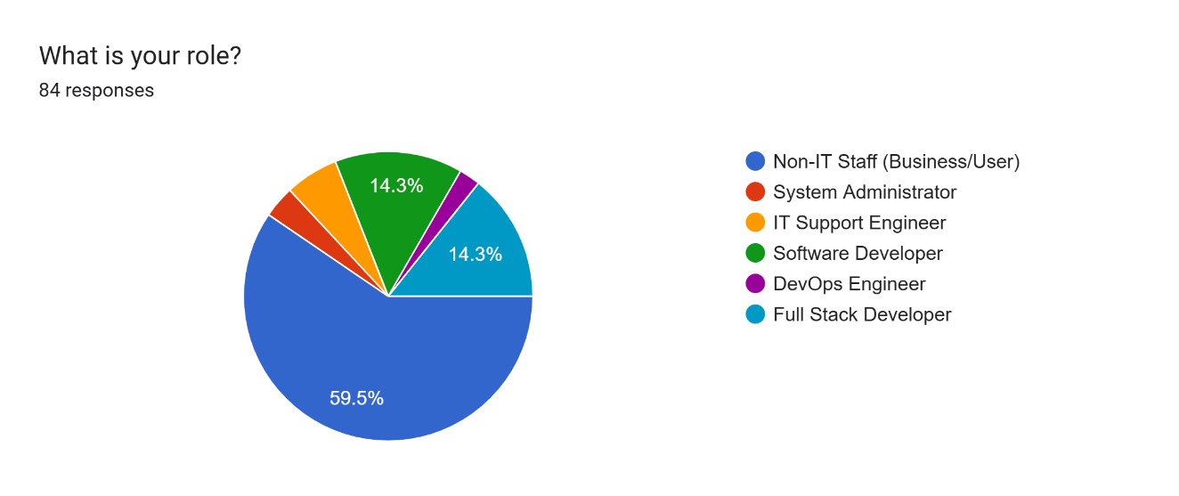
Source: Researcher’s own analysis of primary survey data, April 2026.

2.2.2 Requirement Analysis — Non-IT Staff (Business Users, n = 50)
Fifty respondents identified as Non-IT Staff and answered questions covering their technical background, the types and frequency of issues they encounter, the challenges they face, and their preferences for AI-based support features.
Technical Knowledge Level:
The overwhelming majority of business user respondents reported either basic or intermediate technical knowledge. With 90% falling into these two categories and only 8% reporting advanced knowledge, and 2% reporting no experience, this distribution strongly confirms that the user base expected to interact with the proposed system is largely non-specialist — reinforcing NFR2 (usability for non-technical staff).
Frequency of System Issues:
Responses were heavily concentrated at the ‘rarely’ end of the Likert scale: 92% rated at level 4 (infrequent), with only 6% at level 3 and 2% at level 2. No respondent reported experiencing issues at the highest frequency. While business users do not encounter issues daily, when issues do occur their impact is significant, as subsequent questions confirm.
Figure 2: Frequency of System Issues — Survey Respondents (n = 50).
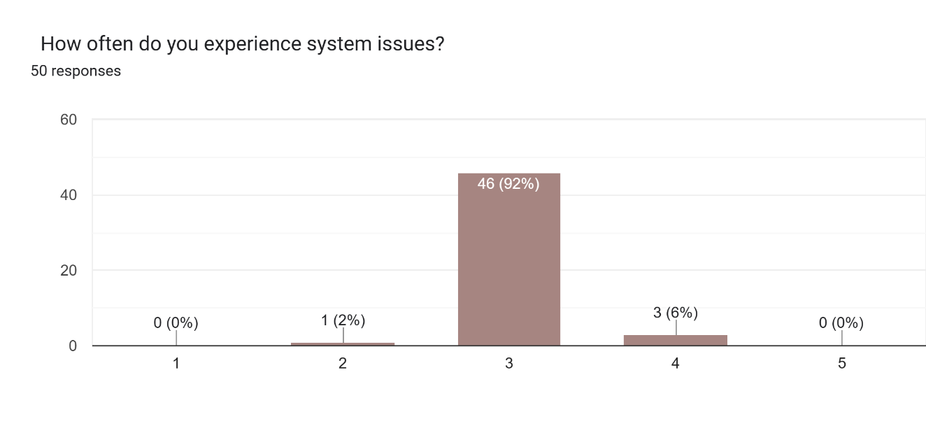
Source: Researcher’s own analysis of primary survey data, April 2026.
Types of Issues Experienced:
Types of system issues experienced by Non-IT Staff (n = 50)
Source: Primary survey data, April 2026 (n = 50). Multiple selections permitted.
Slow system performance was the most frequently reported issue (92%), followed by server/system errors (88%), missing data (86%), and application not loading (84%). System downtime during peak periods was reported by only 8% of respondents. This aligns with the IT staff data showing database issues (76.5%) and performance issues (61.8%) as common problems, confirming that performance degradation is a cross-functional pain point that the proposed Monitoring Agent must address.
Figure 3: Types of Issues Experienced — Survey Respondents (n = 50).
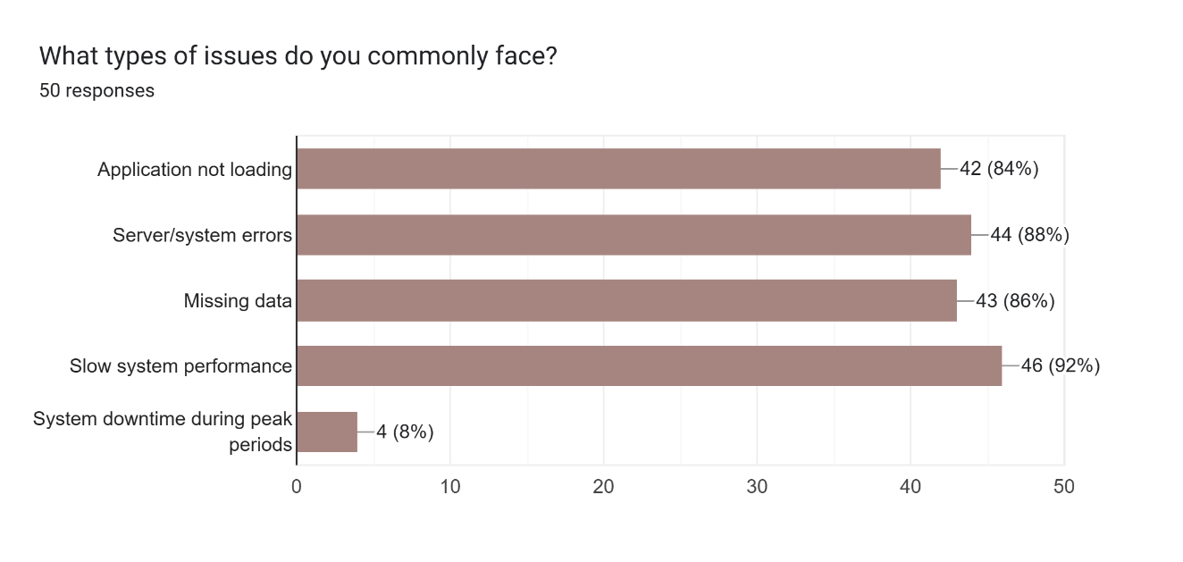
Source: Researcher’s own analysis of primary survey data, April 2026.
Challenges in Establishing Cause:
A striking 92% of non-IT respondents rated cause identification at difficulty level 3 (mid-scale), with 4% at level 1, 2% at level 2, and 2% at level 4. No respondent reported finding cause identification easy overall. This uniformly moderate-to-difficult difficulty rating confirms that business users face significant obstacles in self-diagnosing problems, directly justifying FR2 (automatic root-cause explanation in plain English) as a critical requirement.
Figure 4: Challenges in Establishing Cause — Survey Respondents (n = 50).
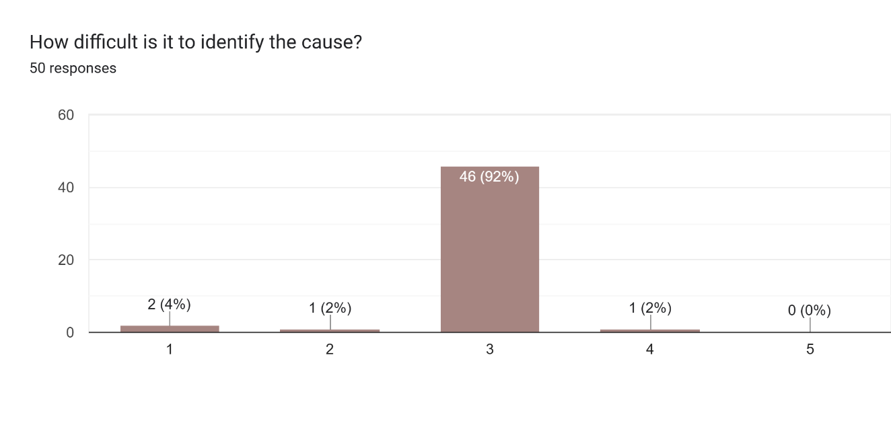 Source: Researcher’s own analysis of primary survey data, April 2026.
Impact on Work:
Reduced productivity was identified as the most significant impact by 90% of non-IT respondents. Task delays were reported by 88%, work stopping completely by 84%, and increased stress by 82%. These figures together demonstrate the profound operational disruption caused by system problems and further strengthen the business case for an accessible, automated administrative assistant.
Figure 5: Impact on Work — Survey Respondents (n = 50).
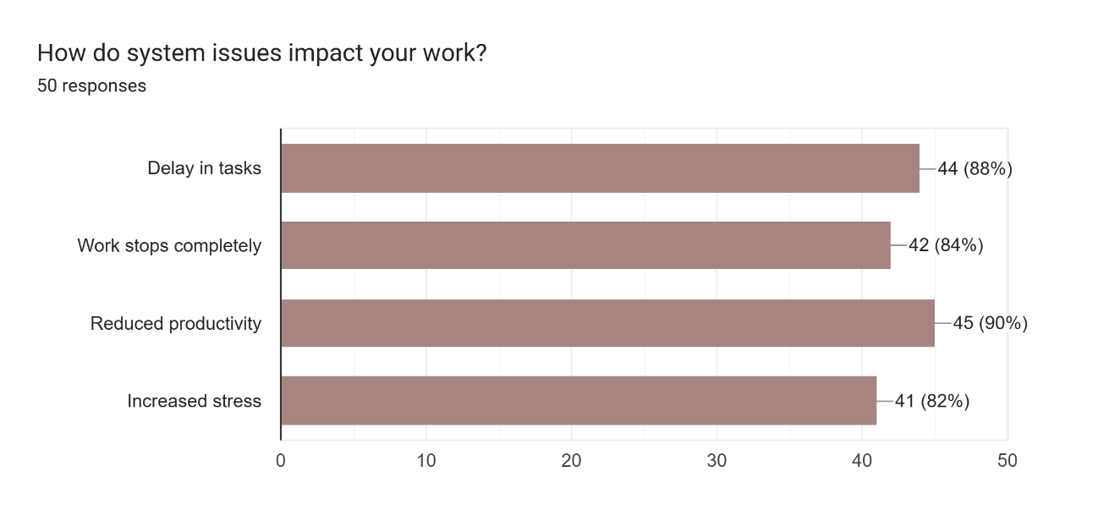
Source: Researcher’s own analysis of primary survey data, April 2026.
Time to Resolution:
The majority of issues were resolved in the 10–30 minute bracket (80%), with 12% taking more than one hour. A small proportion (8%) experienced resolution times of 30–60 minutes. No respondent reported resolution lasting more than one day. While the concentration at 10–30 minutes is an improvement over the previous cohort, the 12% experiencing delays beyond one hour represents a meaningful productivity drain, particularly given the 90% reduced-productivity impact reported above.
Figure 6: Time to Resolution — Survey Respondents (n = 50).
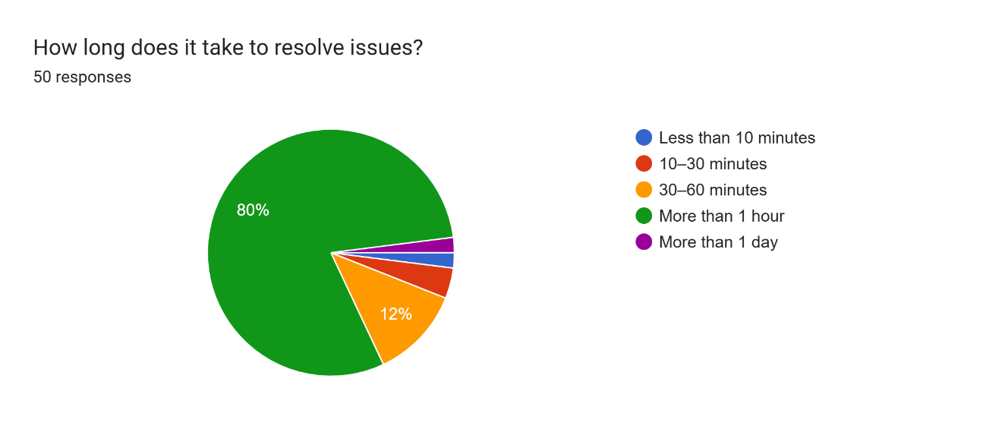
Source: Researcher’s own analysis of primary survey data, April 2026.
Problems When Contacting IT Staff:
The most commonly reported obstacle was IT staff being busy (86%), followed by slow response (80%). Communication gaps were noted by 6%, issue not understood by 2%, and only 8% reported no major problems. The high rate of both ‘IT staff are busy’ and ‘slow response’ validates a resource bottleneck — precisely the inefficiency the proposed solution aims to minimise by enabling non-technical users to run basic diagnostics independently.
Figure 7: Problems When Contacting IT Staff — Survey Respondents (n = 50).
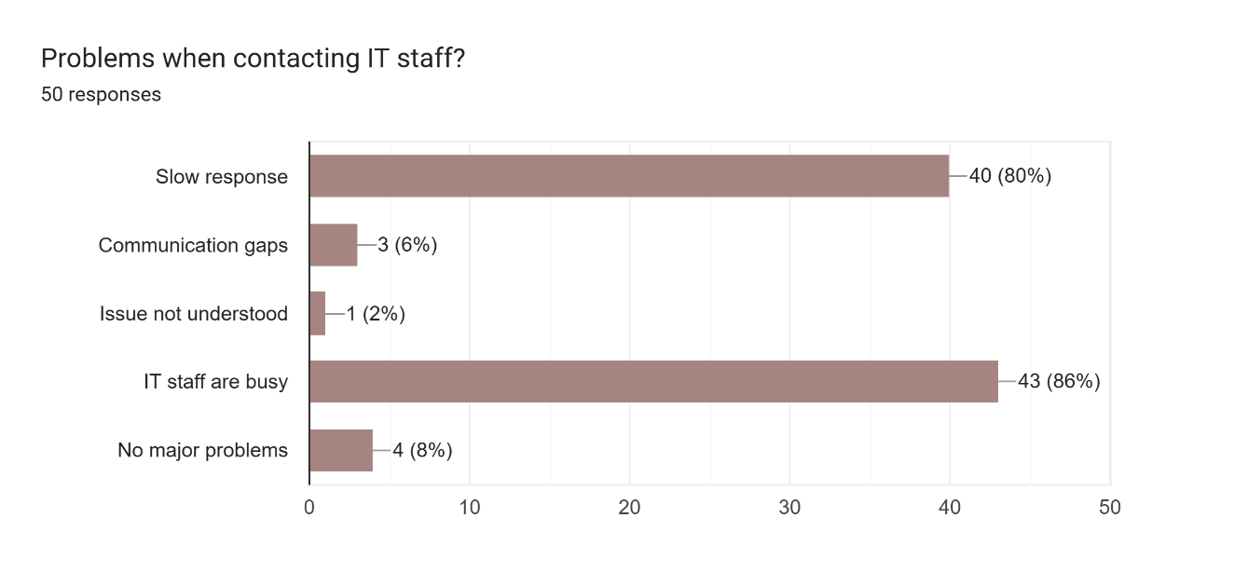
Source: Researcher’s own analysis of primary survey data, April 2026.
Key Findings: AI Help Features
An overwhelming 92% of non-IT respondents confirmed that an AI system explaining faults would be useful, with only 6% indicating Not sure and 2% saying No. This near-unanimous endorsement provides strong empirical justification for the core concept of the proposed system.
Figure 8: Non-IT Staff — Preferred AI System Features (n = 50).
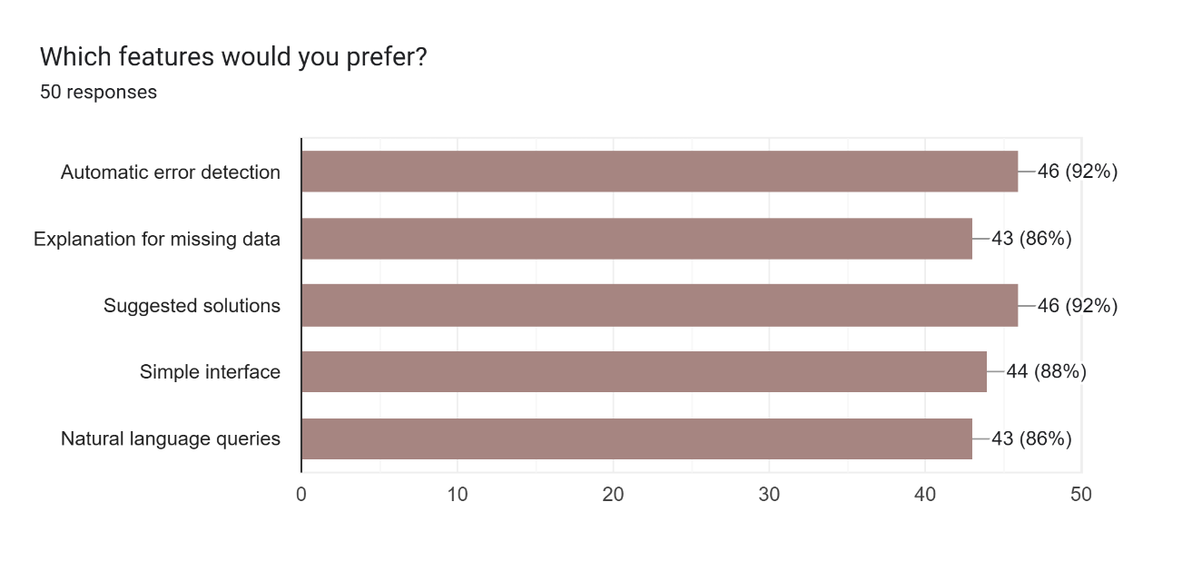
Source: Researcher’s own analysis of primary survey data, April 2026.
Automatic error detection and suggested solutions were equally the most desired features (both 92%), followed by a simple interface (88%), explanation for missing data (86%), and natural language queries (86%). These findings strongly validate FR1 (automated anomaly detection), FR2 (diagnostic feedback), and NFR2 (simple, accessible interface) as the highest-priority requirements from the business-user perspective.
Regarding broader AI impact: 90% confirmed that AI would help non-technical users (Yes), with 10% saying Maybe. On reducing IT dependency, 90% said Maybe and 8% said Yes, with only 2% saying No. These responses demonstrate strong confidence that an AI-based system would yield concrete accessibility gains.

2.2.3 Requirement Analysis — IT Staff and Developers (n = 34)
Thirty-four respondents identified as IT professionals and answered questions covering their experience, the systems they manage, common issues, root-cause identification methods, current tool limitations, and attitudes towards AI-based automation.
Experience and Systems:
The IT respondent group was experienced: 38.2% had more than 5 years of experience, 26.5% had 3–5 years, 23.5% had 1–3 years, and only 11.8% had less than 1 year. This distribution indicates that responses reflect substantial practical expertise. The most prevalent system maintained was databases (76.5%), followed by backend services (67.6%), web applications (61.8%), mobile applications (50%), and cloud systems (41.2%). The dominance of databases and backend services confirms that the proposed system’s integration with MySQL and API-based monitoring addresses the most prevalent IT operational contexts.
Figure 9: IT Staff — Systems Worked With SAP (n = 34).
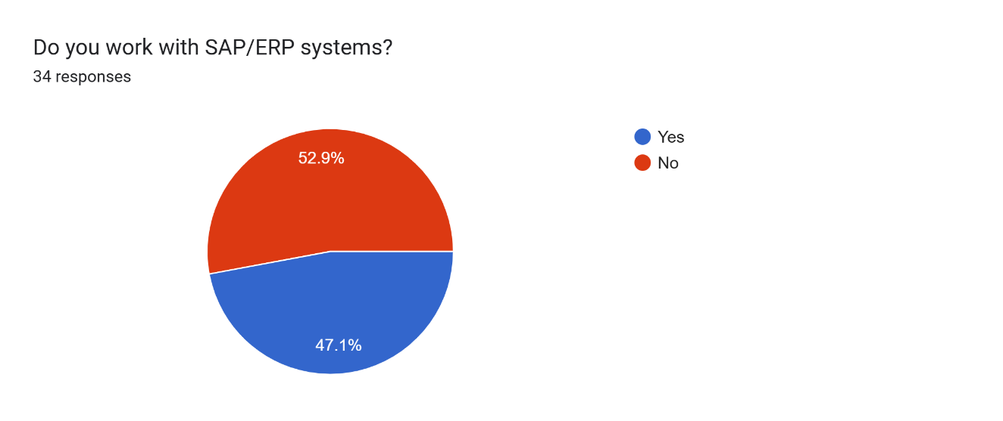
Source: Researcher’s own analysis of primary survey data, April 2026.
Figure 10: IT Staff — Systems Worked With SAP Modules (n = 34).
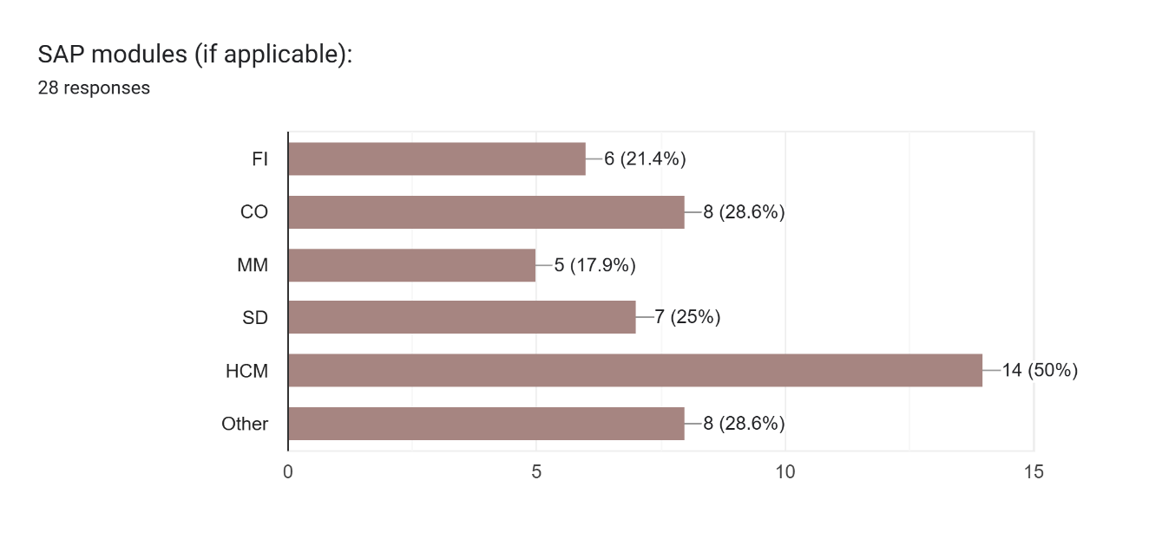
Source: Researcher’s own analysis of primary survey data, April 2026.
52.9% of IT respondents worked with SAP/ERP systems. Among SAP module users (n = 28), HCM (Human Capital Management) was the most common module (50%), followed by CO (Controlling, 28.6%), Other (28.6%), SD (Sales and Distribution, 25%), FI (Financial Accounting, 21.4%), and MM (Materials Management, 17.9%). This broad SAP/ERP exposure confirms the relevance of the proposed system to real-world enterprise environments.
Frequency and Types of Issues:
The distribution of issue-handling frequency was: 47.1% rated at level 3 (moderate frequency), 20.6% at level 2, 11.8% at both levels 1 and 5, and 8.8% at level 4 — indicating that the majority of respondents handle issues at least moderately frequently. Figure 3 shows the distribution of issue types:
Figure 11: IT Staff — Common Issues Handled (n = 34).
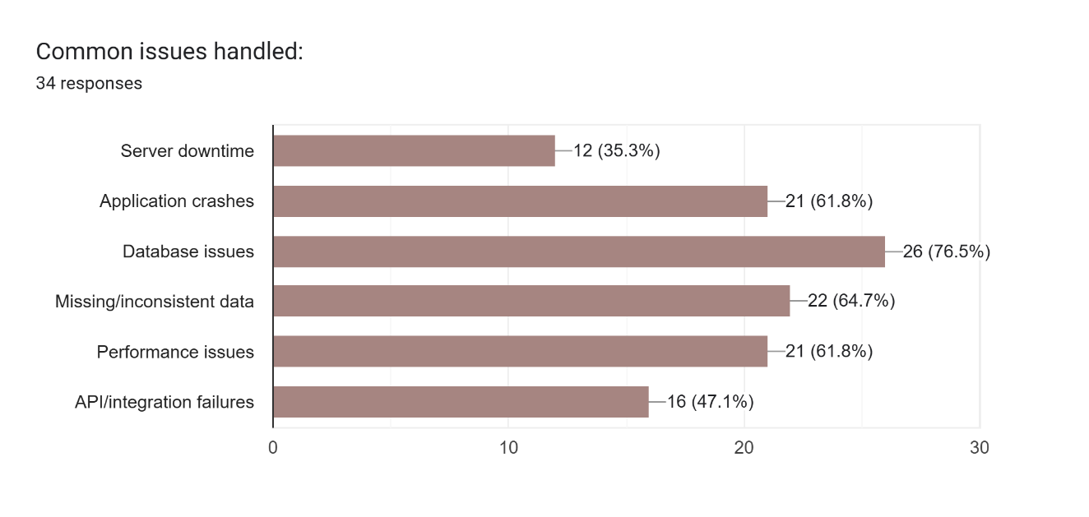
Source: Researcher’s own analysis of primary survey data, April 2026.

Database issues were the most prevalent (76.5%), reinforcing the decision to use MySQL as the core data layer for the prototype. Missing/inconsistent data (64.7%), application crashes (61.8%), and performance issues (61.8%) are all detectable through log monitoring, validating the Monitoring Agent scope. API/integration failures were reported by 47.1% and server downtime by 35.3%.
Root Cause Identification Methods:
IT respondents relied primarily on debugging (76.5%), log analysis (73.5%), and experience (58.8%) to identify root causes, supplemented by team discussion (55.9%) and monitoring tools (44.1%). The dominance of debugging and log analysis as methods — yet 88.2% finding root cause identification difficult (Likert score 3 or 4) — confirms that existing tools do not adequately support these activities. This is the most direct empirical justification for the Analysis and Diagnostic Agent.
Difficulty in Identifying Root Cause:
Of 34 IT respondents, 64.7% rated difficulty at level 3 and 23.5% at level 4 — meaning 88.2% found root cause identification at least moderately difficult. Only 5.9% each rated it at levels 1 or 2 (easy), and no respondent rated it at level 5 (very difficult). This high difficulty rating, combined with heavy reliance on manual debugging and log analysis, confirms a significant unmet need for automated, intelligent diagnostic support.
Current Tool Limitations:
IT Staff: Limitations of current tools (n = 34)
Source: Primary survey data, April 2026 (n = 34). Multiple selections permitted.
Difficult log analysis was the most cited limitation (70.6%), followed by lack of insights (52.9%) and high manual effort (52.9%). Poor integration was noted by 23.5%, while delayed alerts and incomplete data were each reported by 20.6%. These findings confirm the key shortcomings of current tools identified in the literature review: they surface data without providing actionable intelligence.
Resolution Time:
IT staff resolved issues in 30–60 minutes (32.4%), more than 1 hour (35.3%), 10–30 minutes (26.5%), and less than 10 minutes (5.9%). The notable proportion experiencing resolution times exceeding one hour (35.3%) indicates a significant productivity drain where intelligent automated assistance would have considerable impact, helping to reduce resolution times towards the lower end of the range.
Repeated User Issues:
70.6% of IT respondents rated the frequency of repeated user issues at level 3, with 11.8% at both levels 2 and 4, and 2.9% at both levels 1 and 5. This strong concentration at the moderate frequency level indicates that repeat issues are a common occurrence, consuming disproportionate IT capacity and reinforcing the value of automated root-cause analysis to prevent recurrence.
Impact on IT Staff Workflows:
50% of IT respondents reported that handling user-reported issues significantly affected their own work, with 44.1% reporting this happened sometimes and only a small percentage reporting no impact. On user report quality: 47.1% reported that user reports lack technical details, 47.1% said this happens sometimes, and only 5.9% reported no problem. This confirms a critical communication gap between business users and IT teams — one the proposed system addresses by providing automated, structured diagnostic reporting that reduces the burden on both parties.
Attitudes Towards AI-Based Automation:
Figure 12: IT Staff — Useful AI Features (n = 34).
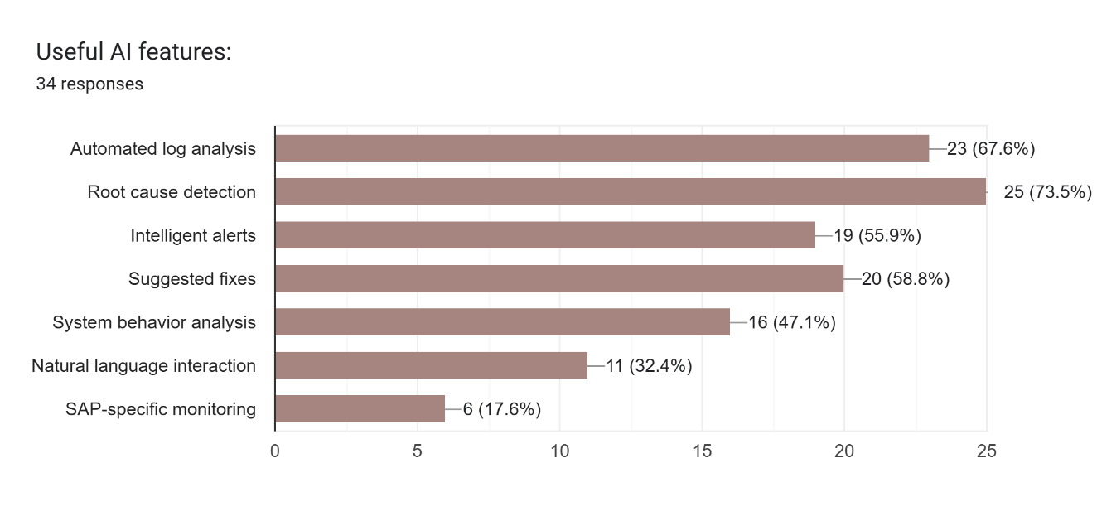
Source: Researcher’s own analysis of primary survey data, April 2026.
Root cause detection was the most valued AI feature (73.5%), followed by automated log analysis (67.6%) and suggested fixes (58.8%). Intelligent alerts were desired by 55.9%, system behaviour analysis by 47.1%, natural language interaction by 32.4%, and SAP-specific monitoring by 17.6%. These features map directly to FR2 (diagnostic feedback), FR1 (log monitoring), and the Diagnostic Agent’s resolution suggestion capability. 82.4% of IT respondents confirmed that AI-based automation would help, and 64.7% stated they would trust AI suggestions, with 32.4% only if accuracy was confirmed. This trust distribution justifies the evaluation strategy’s focus on measurable accuracy metrics to build user confidence.

2.2.4 Open-Ended Responses
Open-ended questions (Q35–Q38) were answered by all respondents. The following selected responses, presented verbatim, illustrate the dominant themes emerging from qualitative analysis.
Q35 — Biggest difficulty when using systems:
- “The biggest difficulty is system complexity and slow performance. Navigating through multiple modules can be confusing, and sometimes transactions take longer to process, which affects productivity.”
- “The biggest difficulty when using systems is complexity (poor usability).”
- “The need to know technology and technical terms.”
- “Some times lack of understanding how system going on.”
- “Logging issue.”
- “Complex implementation.”
Q36 — Time lost due to system issues:
- “On average, I lose around 1–2 hours per week due to system delays, errors, or downtime, especially during peak usage times.”
- “About 30 min – 1 h per day.”
- “60 minutes.”
- “2 hours.”
- “Significant.”
Q37 — Desired improvements:
- “I would like improved system speed, a more user-friendly interface, better integration between modules, and clearer error messages to quickly identify and resolve issues.”
- “Quick solutions and layman terms of showing the problem.”
- “Must track the root cause.”
- “I would like simpler and more user-friendly interfaces.”
- “Share the details among team — well documented and proper handover.”
Q38 — Suggestions for AI-based solutions:
- “We can suggest the path and the root cause and also debugging steps.”
- “Detection, automated error resolution, smart data entry suggestions, and chat-based assistants to help users navigate the system and troubleshoot problems quickly.”
- “One good suggestion is to use AI-powered virtual assistants to guide users and solve issues automatically.”
- “More AI solutions for SAP systems.”
- “Yes — AI should need to use in every system.”
- “Error automatically fixing.”

2.2.5 Requirements Derived from Market Research
The following table maps each functional and non-functional requirement of the proposed system to the specific survey evidence that validates it:
Table 3: Requirements Derived from Survey Evidence
Req. ID | Requirement | Survey Evidence
FR1 | Automated log monitoring & anomaly detection | IT staff (73.5%) use log analysis as primary diagnostic method; database issues (76.5%) and performance problems (61.8%) are most common — both detectable via log monitoring.
FR2 | Root cause analysis with plain-English explanation | 88.2% of IT staff find root cause identification difficult (rating 3–4 of 5); 70.6% cite difficult log analysis as a tool limitation; business users report inability to understand technical errors (80%).
FR3 | Natural language query interface | 92% of non-IT users confirmed an AI error explanation would be useful; natural language queries desired by 86% of non-IT staff.
FR4 | Unified system health dashboard | IT staff use dashboards (50%) but combine them with manual analysis (64.7%) and scripts (58.8%) — indicating no unified view. Tool fragmentation is a key pain point.
FR5 | Role-based access control | Business users and IT staff operate in clearly distinct roles with different access needs; 50% of IT staff report that user issues significantly affect their own work, necessitating controlled access.
NFR1 | Query response within 5 seconds | IT staff report 30–60 minutes (32.4%) and 10–30 minutes (26.5%) resolution times; fast response is critical to reducing time-to-resolution.
NFR2 | Usable by non-technical staff | 90% of non-IT users have basic or intermediate technical knowledge; 92% confirmed an AI error explanation would be useful.
NFR3 | Modular agent architecture | IT staff handle issues across heterogeneous systems: databases (76.5%), backend services (67.6%), web apps (61.8%), mobile apps (50%); modularity enables targeted agent deployment.
Source: Researcher’s own analysis of primary survey data, April 2026.

2.2.6 Market Research Conclusion
The primary market research findings strongly corroborate the literature review conclusions. Across both non-IT (n = 50) and IT (n = 34) respondent groups, a consistent pattern emerged: current tools surface data without providing explanatory or actionable intelligence; diagnostic work is predominantly manual, time-consuming, and difficult; and there is strong, near-unanimous demand for AI-based solutions featuring automated root-cause analysis, log monitoring, and intelligent alerts. The non-IT cohort in particular showed overwhelming endorsement of AI assistance, with 92% confirming that an AI error-explanation system would be useful and equal top-rated preference (92% each) for automatic error detection and suggested solutions. The IT cohort reinforced this with 82.4% endorsing AI-based automation and 88.2% rating root-cause identification as at least moderately difficult. The open-ended responses further confirmed that end users want plain-English explanations and integrated, accessible interfaces — both core design principles of the proposed system. Together, the survey data from 84 respondents provides robust empirical grounding for all seven functional requirements and four non-functional requirements identified in Section 4.3.

3. Section 3: Project Plan

3.1. Description of the Project Plan
This section presents the planned schedule for completing the project from initiation through to final submission on 2 September 2026. The project is structured according to the Agile Software Development Methodology, decomposed into six iterative sprints each delivering a defined set of outputs. The Gantt chart in Section 3.2 provides a comprehensive breakdown of all tasks, subtasks, and milestones with their sprint allocations and dates. The Work Breakdown Structure (WBS) in Section 3.3 organises project scope into discrete, manageable work packages. Section 3.4 summarises completed and pending work as at the date of this report.

3.2. Gantt Chart
Table 4 presents the full project schedule. Milestones are marked with a star symbol (★) and shaded in blue. Top-level tasks are shown in bold; subtasks are indented (→). The Status column uses colour coding: green indicates completed work, amber indicates work in progress, and grey indicates pending work.
Figure 13: Project Gantt Chart — Tasks, Subtasks, Milestones, Start and End Dates
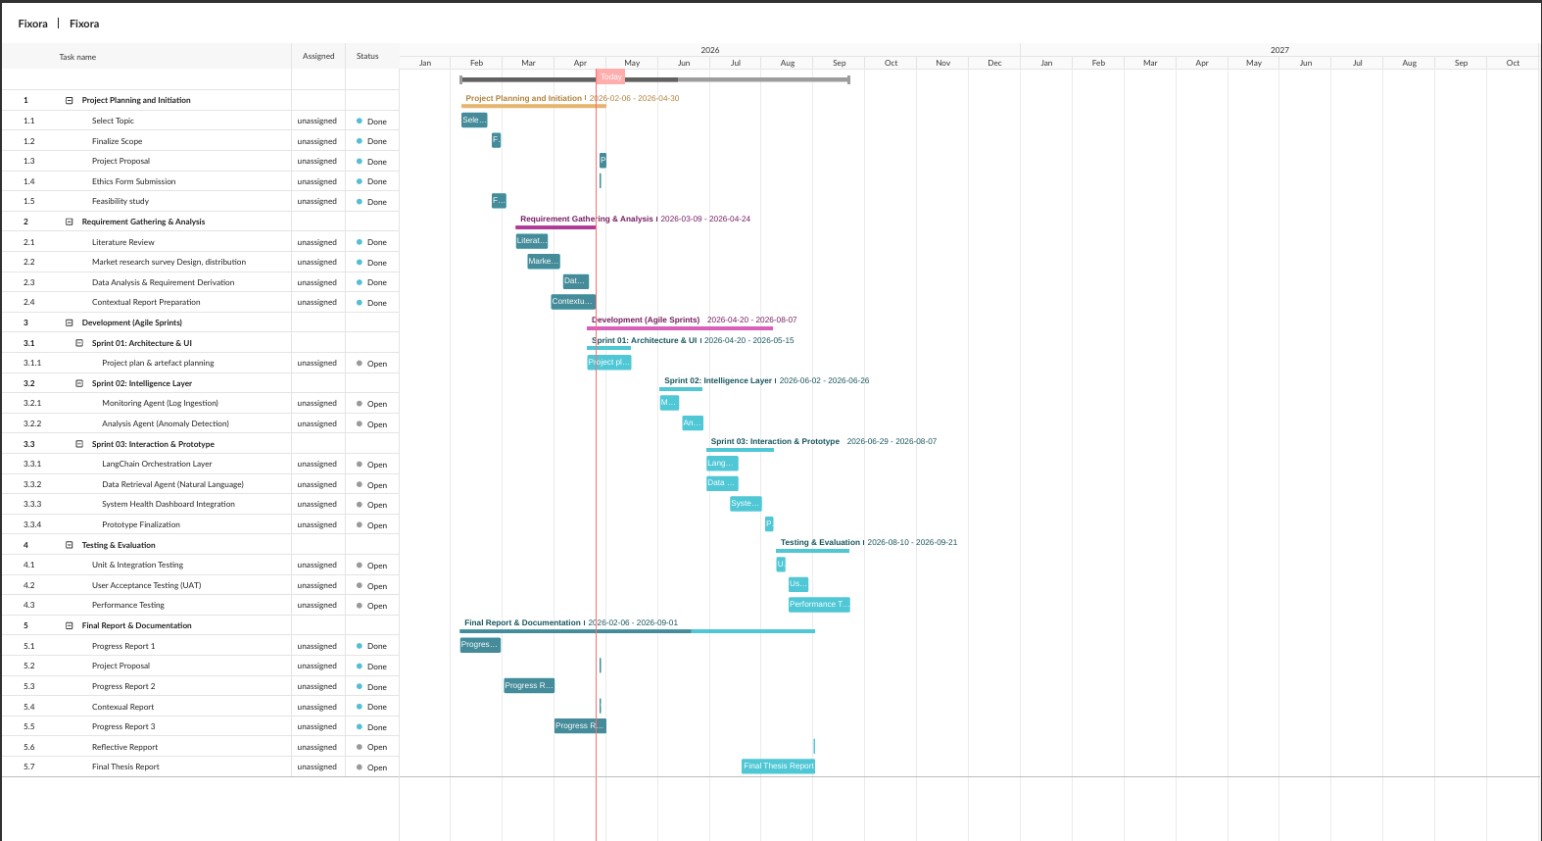
Source: Researcher’s own work.

3.3. Work Breakdown Structure (WBS)
The WBS below decomposes the total project scope into six top-level work packages, each subdivided into component deliverables. It forms the hierarchical foundation from which the Gantt chart tasks and sprint allocations are derived.
Figure 14: Work Breakdown Structure (WBS)

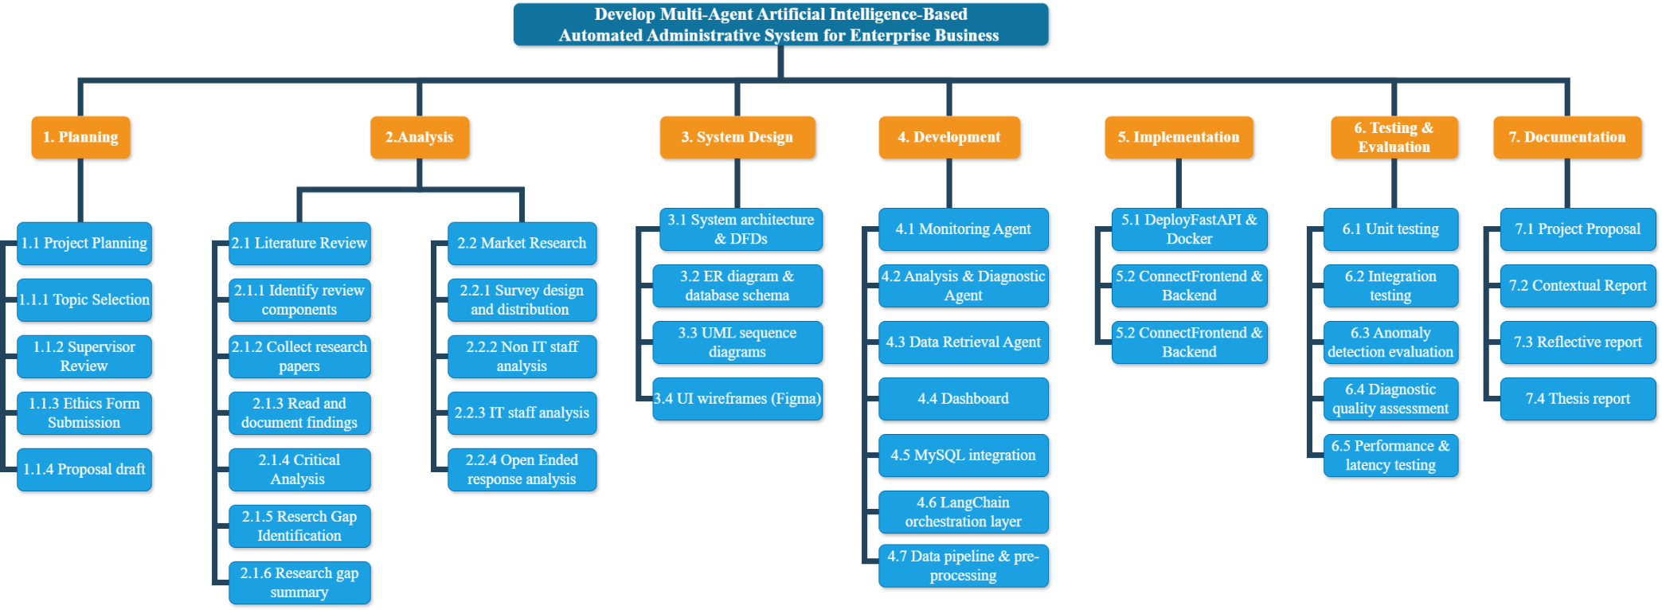
Source: Researcher’s own work.

4. Section 4: Planning Your Artifact

4.1. Methodology
The Agile Software Development Methodology was selected as the guiding framework for the development of the proposed system. This decision was taken after consideration of both Agile and traditional Waterfall approaches and is justified on the following grounds.
Iterative delivery: Agile’s sprint-based structure allows functional components — individual agents, the dashboard, API integration — to be developed, tested, and reviewed incrementally. This is particularly valuable for a research prototype where technical requirements evolve as implementation progresses. Flexibility: the exploratory nature of AI agent development creates inherent uncertainty; Agile accommodates architectural revisions without the plan-revision overhead associated with Waterfall. Supervisor alignment: the regular review cadence built into Agile sprints aligns with scheduled supervisor meetings, providing structured checkpoints for feedback. Risk management: prioritising core features (FR1–FR5) in early sprints ensures a working prototype exists before optional enhancements are attempted, mitigating time-overrun risk — a concern rated High in the risk register (Section 4.8).

4.2. Planning
The planning phase was conducted between February and April 2026. During this phase, the researcher defined and documented the project scope, constructed the Gantt chart (Section 3.2), identified the required technologies and tools (Section 4.5), and assessed the project budget. Since this is an academic prototype, the primary cost centres are commercial AI API access and cloud computing. Grok API (xAI) will be used for natural language processing; usage costs for the prototype are estimated at £30–£50 for the combined development and testing phases, based on expected token volumes. All development frameworks and datasets required are either open-source or freely available for academic use.

4.3. Requirement Gathering and Analysis
Requirement gathering was conducted through two complementary channels, both documented in Section 2. The literature review (Section 2.1) provided systematic examination of the academic and commercial landscape, enabling derivation of requirements from a theoretical and state-of-the-art perspective. The primary market research (Section 2.2) provided empirical grounding from 84 practising IT professionals and business users.
The functional requirements (FRs) are:
- FR1: The system shall monitor enterprise application logs in real time and generate contextualised alerts when anomalous patterns are detected. (Validated by: 76.5% of IT staff handle database issues; 73.5% rely on log analysis; 67.6% desire automated log analysis.)
- FR2: The system shall provide automated diagnostic feedback identifying the most probable root cause of detected anomalies in plain English. (Validated by: 88.2% of IT staff find root cause identification difficult; 73.5% desire root cause detection as top AI feature; non-IT users report cause identification difficulty at 92%.)
- FR3: The system shall support natural language queries for retrieving operational data without requiring SQL expertise. (Validated by: 92% of non-IT users confirmed AI error explanation would be useful; NLP query support desired by 86% of non-IT staff.)
- FR4: The system shall present a unified dashboard displaying real-time system health metrics, alert history, and agent activity. (Validated by: 50% of IT staff use dashboards but combine with manual analysis (64.7%) and scripts (58.8%) — indicating no unified view. Tool fragmentation is a key pain point across both groups.)
- FR5: The system shall implement RBAC supporting at least two user roles: administrator (full access) and viewer (read-only). (Validated by: distinct role separation confirmed by participant demographics; 50% of IT staff significantly affected by user-reported issues requiring controlled access.)
The non-functional requirements (NFRs) are:
- NFR1: The system shall return responses to natural language queries within five seconds under normal load. (Survey: 32.4% of IT staff spend 30–60 minutes on issue resolution; fast query response is essential.)
- NFR2: The user interface shall be usable by non-technical staff without specialist training. (Survey: 90% of non-IT users have basic or intermediate technical knowledge.)
- NFR3: The system architecture shall be modular, enabling independent development, testing, and replacement of individual agents. (Survey: IT staff manage heterogeneous systems — databases 76.5%, backend 67.6%, web apps 61.8%.)
- NFR4: The system shall process a minimum test dataset of 10,000 log entries without performance degradation.

Proposed Conceptual Framework
The proposed system is architecturally decomposed into three cooperating subsystems: a perception layer (Monitoring Agent performing real-time log ingestion and threshold alerting via Isolation Forest anomaly detection), a reasoning layer (Analysis and Diagnostic Agent applying Drain log parsing, Random Forest classification for known anomaly patterns, and Grok (xAI)-powered root-cause generation), and an interaction layer (Data Retrieval Agent and React.js dashboard enabling schema-aware NLP querying and result visualisation). What distinguishes this architecture from existing commercial platforms — Datadog, Splunk, and New Relic — is the explicit integration of all three layers within a LangChain orchestration framework enabling autonomous agent collaboration: anomaly signals generated by the perception layer are automatically routed to the reasoning layer, whose outputs are made accessible through the interaction layer without requiring human triage at each stage. No existing product in the reviewed literature or commercial market implements this complete pipeline. The conceptual novelty lies not in any individual component — each draws on established techniques — but in their coordinated integration within a single, purpose-built enterprise administration system that serves both technical and non-technical users through a unified, role-based interface.

Illustrative Use Case Scenario
To make the system’s operation concrete, consider the following scenario. At 09:15, a junior administrator notices a dashboard alert indicating elevated error rates in a MySQL transaction log. Rather than manually parsing thousands of log entries, the administrator types: “What caused the database slowdown in the last hour?” The Data Retrieval Agent translates this into a structured SQL query against the operational log database. Simultaneously, the Monitoring Agent has already flagged an anomalous latency spike at 09:07, routing the event to the Analysis Agent, which applies Isolation Forest to isolate the anomalous log window and identifies a recurring deadlock pattern between two competing write transactions. The Diagnostic Agent then invokes Grok (xAI) with the structured anomaly context and system schema, generating the plain-English response: “A likely deadlock condition was detected between write transactions on the Orders and Inventory tables at 09:07–13. Recommend reviewing transaction isolation level and index configuration on Orders.OrderID.” The full pipeline executes within the NFR1 five-second threshold. This scenario validates FR1 (automated log monitoring), FR2 (plain-English root-cause explanation), FR3 (natural language querying), and FR4 (unified dashboard), and illustrates how the proposed architecture can reduce diagnostic time from hours of manual investigation to seconds of automated analysis.

4.4. Design
The system design phase will be conducted during Sprint 2 in May 2026. The following artefacts will be produced:
- System Architecture Diagram: A high-level diagram illustrating the four AI agents (Monitoring, Analysis/Diagnostic, Data Retrieval), the LangChain Orchestration Layer, the MySQL database, the FastAPI backend, and the React.js dashboard, produced using draw.io or Microsoft Visio.
- Data Flow Diagrams (Level 0 and Level 1): Modelling data flows between system components — log ingestion, agent routing, NLP processing, database querying, and response generation.
- Entity Relationship (ER) Diagram: Modelling the relational database schema covering log records, user accounts and roles, system alerts, agent outputs, and operational data, produced using MySQL Workbench.
- Sequence Diagrams: UML sequence diagrams for two key flows — (1) a natural language diagnostic query through the full agent pipeline; (2) the automated log monitoring and alert workflow.
- Wireframes: Figma-based prototypes covering the main dashboard, log monitoring view, NLP query interface, alert management panel, and RBAC user settings screen.
Figure 6 below represents a high-level conceptual view of the proposed system architecture, illustrating the agent structure and principal information flows between components.
Figure 15: High-Level Conceptual System Architecture of the Proposed Multi-Agent AI System.
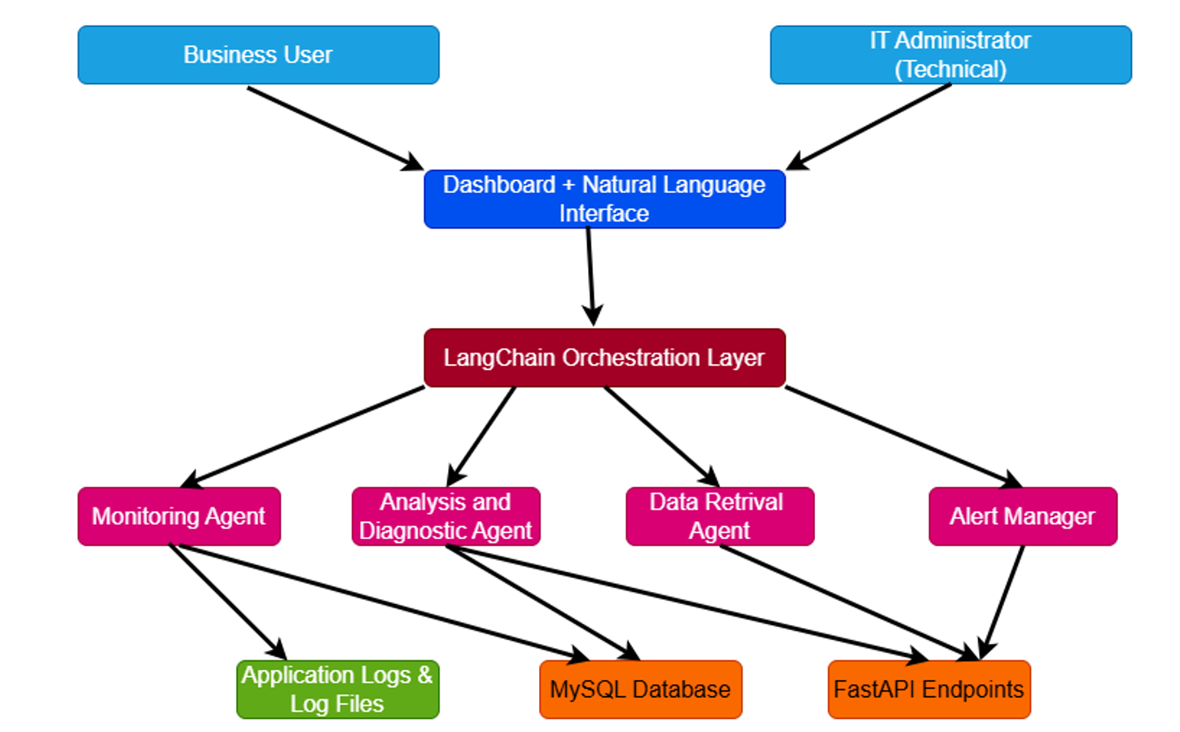
Source: Researcher’s own work.

4.5. Implementation
Implementation will take place across Sprints 3 and 4 (June–July 2026), following design sign-off. A bottom-up approach will be adopted: each agent will be developed and unit-tested independently before integration through the LangChain orchestration layer.
Table 4: Technologies and Tools Selected for System Implementation
Technology / Tool | Category | Role in System
Python | Backend / AI Core | Primary language for agent logic, data processing, and API development.
LangChain | Agent Framework | Orchestrates multi-agent coordination, tool routing, and context management.
Grok API (xAI) | Large Language Model | Natural language understanding, query interpretation, diagnostic text generation, and root-cause reasoning via the Grok API.
FastAPI | REST API Layer | Exposes agent capabilities as API endpoints consumed by the frontend dashboard.
MySQL | Relational Database | Stores operational data, log records, user profiles, and agent outputs.
React.js | Frontend Framework | Interactive user dashboard with real-time data visualisation components.
Pandas / NumPy | Data Processing | Log file parsing, pre-processing, and statistical feature extraction.
Scikit-learn | ML Library | Anomaly detection model training, classification, and evaluation.
Docker | Containerisation | Consistent, reproducible deployment environment across development and testing.
Figma | UI Prototyping | Wireframe and prototype design for the dashboard interface.
MySQL Workbench | DB Design | ER diagram creation and database schema management.
Kaggle Datasets | Test Data | Publicly available enterprise log and operational datasets for prototype testing.
GitHub | Version Control | Source code management, issue tracking, and collaboration.
VS Code / PyCharm | IDE | Development environments for Python backend and React frontend.
Source: Researcher’s own selection based on literature review, market research, and technical feasibility assessment.
The primary dataset for prototype testing will be a publicly available enterprise server log dataset sourced from Kaggle, pre-processed using Pandas to remove null values, normalise timestamp formats, and annotate anomaly classes. A secondary dataset of structured SQL query logs will be used to evaluate the Data Retrieval Agent’s natural language-to-SQL translation accuracy.

4.6. Testing and Evaluation Strategy
- Unit Testing: Each AI agent will be tested in isolation using the pytest framework, covering standard operation (normal log inputs, well-formed queries), boundary conditions (empty inputs, malformed log entries), and edge cases (conflicting agent responses, database connectivity failures).
- Integration Testing: The full agent pipeline will be tested end-to-end, verifying correct LangChain orchestration routing, accurate response aggregation, and correct FastAPI serving to the dashboard.
- User Acceptance Testing (UAT): A group of five to eight participants representing both technical (IT administrators) and non-technical (managers, junior staff) user profiles will complete structured task-based evaluation followed by a post-session questionnaire.
- Performance Testing: The system will be subjected to a 10,000-entry log dataset (NFR4), with query response times measured against the five-second threshold (NFR1) and resource utilisation monitored via Docker container metrics.
4.7 Evaluation Strategy
- Anomaly Detection Accuracy: The Analysis Agent’s Isolation Forest outputs will be evaluated against labelled ground-truth anomaly instances in the Kaggle log dataset using precision, recall, F1-score, and ROC-AUC metrics (FR1). To establish empirical rigour, results will be benchmarked against two baselines: (1) a rule-based threshold monitor representing current industry practice, and (2) PCA-based log analysis as documented by Xu et al. (2009), enabling quantified improvement claims over the state of the art.
- Diagnostic Quality: A panel of three practising IT professionals will independently assess ten Diagnostic Agent outputs using a structured rubric scored on accuracy (does the root cause match the ground truth?), clarity (is the explanation understandable to a non-specialist?), and actionability (does it recommend a concrete remediation step?) on a five-point Likert scale (FR2). Inter-rater reliability will be assessed using Cohen’s Kappa to confirm consistency of judgement across evaluators.
- NLP Query Success Rate: The Data Retrieval Agent will be evaluated on a test set of 30 natural language queries, stratified by complexity (10 simple, 10 moderate, 10 complex), with success defined as generation of SQL that returns the correct result set when executed against the operational database. Partial credit will be awarded for syntactically valid but semantically incomplete SQL, and all queries will be validated against a manually constructed ground-truth SQL equivalence set (FR3).
- Usability Score: UAT participants (n = 5–8, stratified by technical background: IT professionals and business users) will complete structured task-based evaluation followed by the System Usability Scale (SUS), a validated ten-item questionnaire providing a standardised usability score. A target SUS score of ≥68 (above-average usability) has been set as the acceptance threshold, consistent with published SUS benchmarks (NFR2).
- Response Latency: Mean and 95th-percentile end-to-end response times will be measured across 100 queries under simulated concurrent load and compared against the NFR1 five-second threshold using a one-sample t-test to determine statistical significance of compliance.
- Evaluation Limitations: The evaluation acknowledges inherent constraints that must be transparently reported in the final thesis. The Kaggle log dataset, while representative of enterprise server logs, may not capture the full structural heterogeneity of production enterprise environments, potentially limiting external validity. The panel of three IT professionals is small for inter-rater reliability analyses, and results should be interpreted accordingly. Grok API performance may vary with model updates during the evaluation window, introducing a degree of non-determinism. These limitations will be addressed through transparent reporting and, where possible, multiple evaluation runs to assess result stability.

4.7. Risks and Risk Mitigation
Table 7 presents the risk register, identifying eight key risks with their assessed impact, likelihood, and mitigation strategies:
Table 5: Risk Register and Mitigation Strategies
Risk Description | Impact | Likelihood | Mitigation Strategy
Scope too large / complex automation workflow | High | High | Define and document scope at project initiation; adopt phased sprint deliverables; defer non-core features.
Limited experience with multi-agent AI frameworks | Medium | Medium | Begin with a basic single-agent prototype; iteratively introduce LangChain coordination; use official documentation and examples.
Difficulty coordinating multiple AI agents | Medium | Medium | Develop and unit-test each agent in isolation before integration; use modular architecture with well-defined interfaces.
Low-quality or unrealistic test datasets | Medium | Medium | Validate and clean all Kaggle datasets before use; cross-reference with academic benchmarks; apply EDA.
Performance issues with large log datasets | Low | Low | Limit prototype dataset to a moderate size (≤ 100,000 records); profile performance during Sprint 5.
Time limitations during development | High | Medium | Apply Agile with fixed six-week sprint cycles; prioritise core features (FR1–FR5) in early sprints; weekly supervisor review.
AI model producing misleading or inaccurate outputs | Medium | Medium | Implement output validation checks; evaluate diagnostic accuracy against labelled ground-truth data during Sprint 5.
API cost overrun (xAI Grok usage fees) | Low | Low | Monitor API call volume; use Grok (standard tier) during development, Grok (advanced tier) for final evaluation; budget £30–£50.
Source: Researcher’s own analysis.

5. References
Wooldridge, M. and Jennings, N.R. (1995) ‘Intelligent agents: Theory and practice’, The Knowledge Engineering Review, 10(2), pp. 115–152. doi: 10.1017/S0269888900008122.

Wooldridge, M. (2012) An Introduction to MultiAgent Systems. 2nd edn. Chichester: Wiley.

Shoham, Y. and Leyton-Brown, K. (2009) Multiagent Systems: Algorithmic, Game-Theoretic, and Logical Foundations. Cambridge: Cambridge University Press.

Russell, S. and Norvig, P. (2021) Artificial Intelligence: A Modern Approach. 4th edn. Harlow: Pearson.

Dorri, A., Steger, M., Kanhere, S.S. and Jurdak, R. (2018) ‘Blockchain: A distributed solution to automotive security and privacy’, IEEE Communications Magazine, 56(12), pp. 119–125. doi: 10.1109/MCOM.2018.1700879.

He, Q., Lou, J.-G., Zhang, H. and Li, J. (2016) ‘Experience report: System log analysis for anomaly detection’, Proceedings of the IEEE International Symposium on Software Reliability Engineering (ISSRE), pp. 207–218. doi: 10.1109/ISSRE.2016.21.

Xu, W., Huang, L., Fox, A., Patterson, D. and Jordan, M.I. (2009) ‘Detecting large-scale system problems by mining console logs’, Proceedings of the ACM Symposium on Operating Systems Principles (SOSP), pp. 117–132. doi: 10.1145/1629575.1629577.

Fu, Q., Lou, J.-G., Wang, Y. and Li, J. (2009) ‘Execution anomaly detection in distributed systems through unstructured log analysis’, Proceedings of the IEEE International Conference on Data Mining (ICDM), pp. 149–158. doi: 10.1109/ICDM.2009.87.

Cinque, M., Cotroneo, D. and Pecchia, A. (2013) ‘Event logs for the analysis of software failures: A rule-based approach’, IEEE Transactions on Reliability, 62(4), pp. 832–845. doi: 10.1109/TR.2013.2259200.

Dang, D., Lin, Q. and Huang, P. (2019) ‘Deep learning-based anomaly detection for system logs’, arXiv. Available at: https://arxiv.org/abs/1909.12389

Notaro, M., Di Tria, F. and Di Nitto, E. (2021) ‘AIOps: Real-world challenges and research directions’, IEEE Software, 38(1), pp. 90–97. doi: 10.1109/MS.2020.3023682.

xAI (2025) ‘Agentic AI systems’. Available at: https://x.ai

6. Appendices

6.1. Appendix A: Questionnaire/Interview Questions
Appendix A: Market Research Questionnaire
A.1 Full Questionnaire
The following questionnaire was designed by the researcher and distributed to IT professionals and business users via Google Forms between March and April 2026. Participation was voluntary and anonymous. Branching logic directed Non-IT Staff to Questions 1–16 and IT Staff / Developers to Questions 17–34; Questions 35–38 (open-ended) were answered by all respondents.
SECTION FOR ALL RESPONDENTS
- Q1. What is your role? (Non-IT Staff / System Administrator / IT Support Engineer / Software Developer / DevOps Engineer / Full Stack Developer)
SECTION FOR NON-IT STAFF (Business Users) — Q2 to Q16
- Q2. What is your level of technical knowledge? (No experience / Basic / Intermediate / Advanced)
- Q3. How often do you experience system issues? (Scale 1 = Very Often to 5 = Rarely)
- Q4. What types of issues do you commonly face? (Application not loading / Server/system errors / Missing data / Slow system performance / System downtime during peak periods)
- Q5. When do these issues mostly occur? (Normal working hours / Peak periods / Randomly / Rarely)
- Q6. When issues occur, what do you usually do? (Contact IT support / Contact developer / Try to fix it myself / Wait for someone else / Ignore)
- Q7. How difficult is it to identify the cause? (Scale 1 = Very Easy to 5 = Very Difficult)
- Q8. What challenges do you face? (Cannot understand system errors / Cannot identify missing data / System downtime affects work / Difficulty understanding technical details / Takes too long to resolve / Dependence on IT staff)
- Q9. How long does it take to resolve issues? (Less than 10 mins / 10–30 mins / 30–60 mins / More than 1 hour / More than 1 day)
- Q10. How do system issues impact your work? (Delay in tasks / Work stops completely / Reduced productivity / Increased stress)
- Q11. Problems when contacting IT staff? (Slow response / Communication gaps / Issue not understood / IT staff are busy / No major problems)
- Q12. Do delays in IT support affect your work? (Yes / No / Sometimes)
- Q13. Would an AI system that explains errors be useful? (Yes / No / Not sure)
- Q14. Which features would you prefer? (Automatic error detection / Explanation for missing data / Suggested solutions / Simple interface / Natural language queries)
- Q15. Would it help non-technical users? (Yes / No / Maybe)
- Q16. Would it reduce dependency on IT staff? (Yes / No / Maybe)
SECTION FOR IT STAFF / DEVELOPERS — Q17 to Q34
- Q17. Years of experience in IT. (Less than 1 year / 1–3 years / 3–5 years / More than 5 years)
- Q18. Systems you work with. (Web applications / Databases / Backend services / Cloud systems / Mobile applications)
- Q19. Do you work with SAP/ERP systems? (Yes / No)
- Q20. SAP modules if applicable. (FI / CO / MM / SD / HCM / Other)
- Q21. How often do you handle system issues? (Scale 1 = Very Often to 5 = Rarely)
- Q22. Common issues handled. (Server downtime / Application crashes / Database issues / Missing/inconsistent data / Performance issues / API/integration failures)
- Q23. How do you identify root causes? (Log analysis / Monitoring tools / Debugging / Experience / Team discussion)
- Q24. Difficulty in identifying root cause. (Scale 1 = Very Easy to 5 = Very Difficult)
- Q25. Tools you use. (Log monitoring tools / Dashboards / Scripts / Manual analysis)
- Q26. Limitations of current tools. (Lack of insights / High manual effort / Difficult log analysis / Poor integration / Delayed alerts / Incomplete data)
- Q27. Time to resolve issues. (Less than 10 mins / 10–30 mins / 30–60 mins / More than 1 hour / More than 1 day)
- Q28. Frequency of repeated user issues. (Scale 1 = Very Often to 5 = Rarely)
- Q29. Do user reports lack technical details? (Yes / No / Sometimes)
- Q30. Does handling user issues affect your work? (Yes significantly / Sometimes / No)
- Q31. Would AI-based automation help? (Yes / No / Not sure)
- Q32. Useful AI features. (Automated log analysis / Root cause detection / Intelligent alerts / Suggested fixes / System behaviour analysis / Natural language interaction / SAP-specific monitoring)
- Q33. Would it reduce workload? (Yes / No / Maybe)
- Q34. Would you trust AI suggestions? (Yes / No / Depends on accuracy)
OPEN-ENDED QUESTIONS — ALL RESPONDENTS
- Q35. What is the biggest difficulty you face when using systems? (Open-ended)
- Q36. How much time do you lose due to system issues? (Open-ended)
- Q37. What improvements would you like in such systems? (Open-ended)
- Q38. Any suggestions for AI-based solutions? (Open-ended)
A.2 Selected Open-Ended Responses
The following responses were selected as representative of the dominant themes from qualitative analysis of Q35–Q38:
Q35 — Biggest difficulty when using systems (14 responses):
- “The biggest difficulty is system complexity and slow performance. Navigating through multiple modules can be confusing, and sometimes transactions take longer to process, which affects productivity.”
- “The biggest difficulty when using systems is complexity (poor usability).”
- “The need to know technology and technical terms.”
- “Some times lack of understanding how system going on.”
- “Complex implementation.”
- “Logging issue.”
Q36 — Time lost due to system issues (15 responses):
- “On average, I lose around 1–2 hours per week due to system delays, errors, or downtime, especially during peak usage times.”
- “About 30 min – 1 h per day.”
- “60 minutes.”
- “2 hours.”
Q37 — Desired improvements (12 responses):
- “I would like improved system speed, a more user-friendly interface, better integration between modules, and clearer error messages to quickly identify and resolve issues.”
- “Quick solutions and layman terms of showing the problem.”
- “Must track the root cause.”
- “I would like simpler and more user-friendly interfaces.”
- “Share the details among team — well documented and proper handover.”
Q38 — Suggestions for AI-based solutions (11 responses):
- “We can suggest the path and the root cause and also debugging steps.”
- “Detection, automated error resolution, smart data entry suggestions, and chat-based assistants to help users navigate the system and troubleshoot problems quickly.”
- “One good suggestion is to use AI-powered virtual assistants to guide users and solve issues automatically.”
- “More AI solutions for SAP systems.”
- “Yes — AI should need to use in every system.”
- “Error automatically fixing.”

